Archi diagram

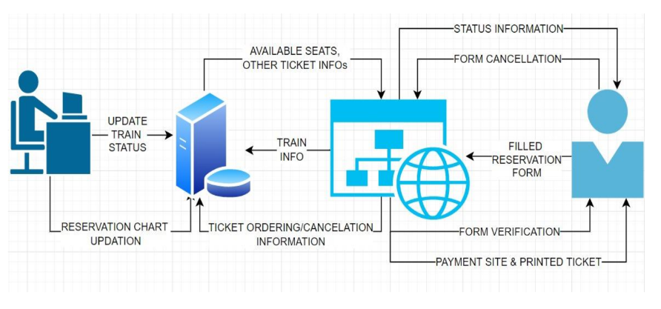

Modify to it bus booking

uml

<https://www.freeprojectz.com/uml-diagram/bus-booking-system-uml-diagram>